CURRENT REQUIREMENTS OF OUR CLINICAL PARTNERS*
REQUIRED TO PARTICIPATE IN THE RN PROGRAM AT SVC
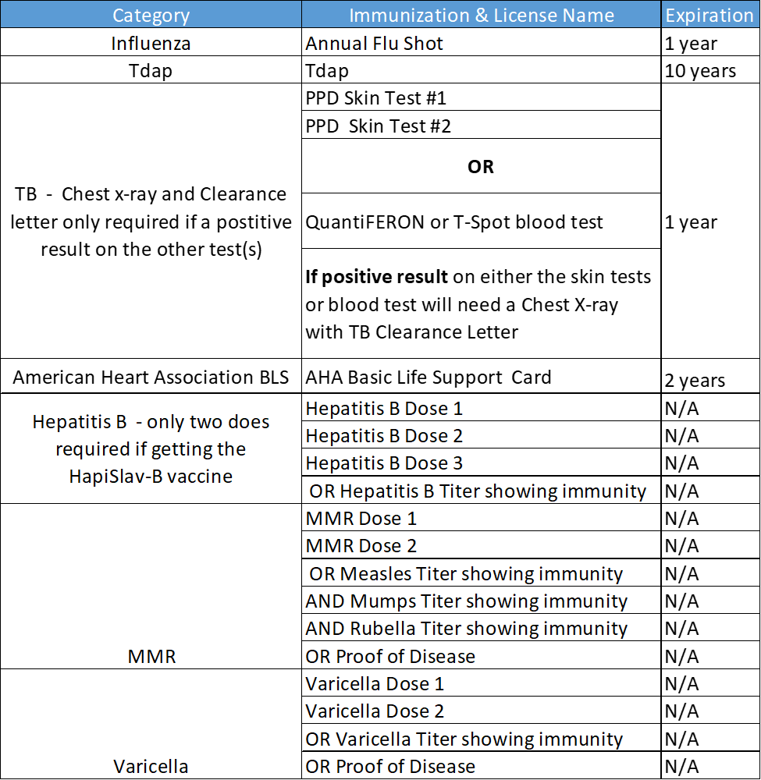*There may be additional immunizations required. We adhere to our clinical agency requirements and there could be changes at any time.

